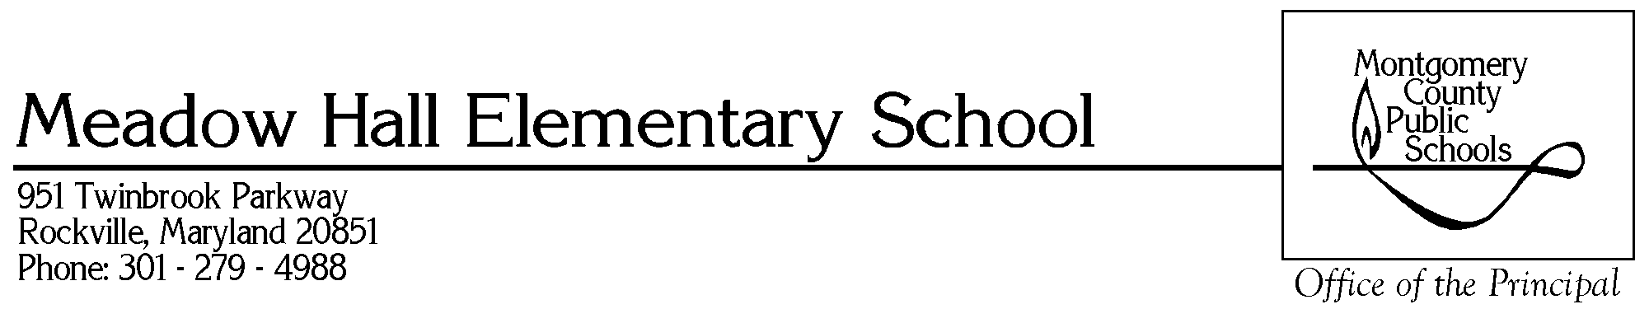

A respectful, safe, fun, and nurturing learning community that encourages innovative ideas, communicates effectively among all stakeholders, and provides consistently high expectations for academic achievement and well-prepared individuals who contribute to society.

Dear Parents/Guardians:

Montgomery County Public Schools is taking an active role in the prevention of child abuse and neglect through early prevention and intervention education.

During the months of September - October, our school counselor and classroom teachers will be presenting lessons on the topic of child abuse and neglect. The lessons are known as Personal Body Safety Lessons and their purpose is to help students to:
- Develop knowledge, decision making skills, and behaviors which promote safe living in the home, school, and community;
- Learn skills for self-protection and identifying child abuse and neglect;
- Learn skills for asking for help for self and others and practice reporting to a trusted adult; and
- Engage in positive and appropriate interactions with peers and adults.

If you have any questions or concerns about the topics that will be covered, please contact me, your child’s classroom teacher, or the school counselor.

Sincerely,

Mr. Cabell Lloyd
Principal

